**SOFTWARE ENGINEERING METHODOLOGY**

The project is going to use the Waterfall methodology. This is an approach to software development that involves a linear and sequential process. The process consists of a set of predefined phases that must be completed in order. The phases are:

1. Requirement gathering and analysis
2. System Design
3. Implementation
4. System Testing
5. System Deployment
6. System Maintenance

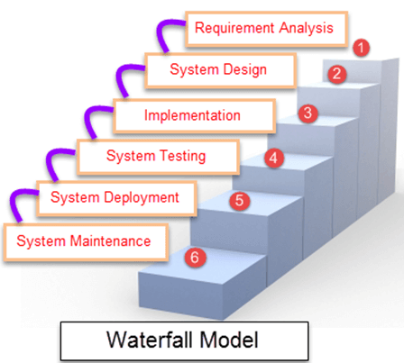

**Project Use Case Model**

The below use case diagram illustrates the various interactions between the user and the dietitian consultant and the diet planner software application.

The "User" can perform three primary actions: plan their diet, track their progress, and manage their diet goals. These actions are represented in the diagram as "Plan Diet," "Track Progress," and "Manage Goals." The "Dietitian" can provide nutritional advice and track the user's progress in achieving their diet goals.

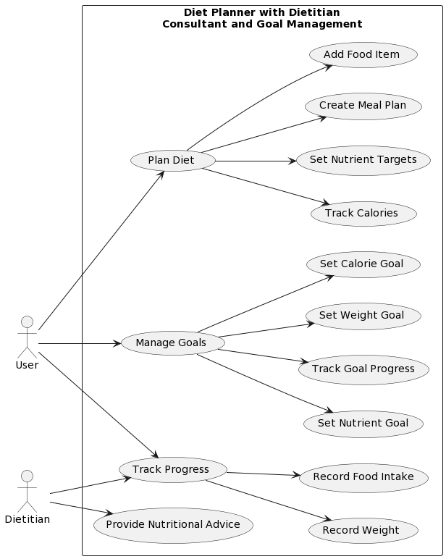

**System Modelling**

Context model

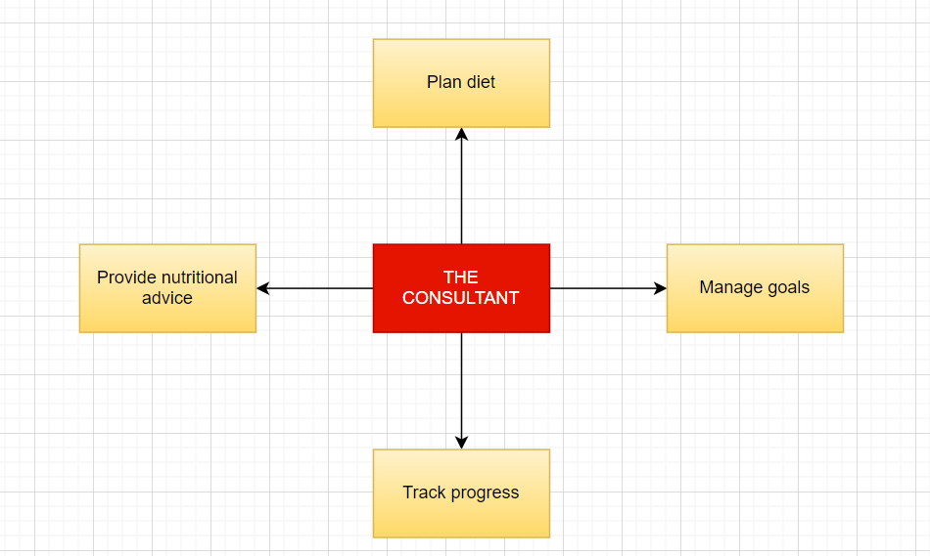

The User interacts with the software application by the following:

* Plan Diet - to plan their diet by creating a meal plan, adding food items, tracking calories, and setting nutrient targets.
* Track Progress - to record their weight and food intake, and track their progress.
* Manage Goals- to manage their diet goals by setting weight, calorie, and nutrient goals, and track their progress.

In addition, the Dietitian interacts with the software application by providing nutritional advice to the user and also tracks their progress.

Interaction Model

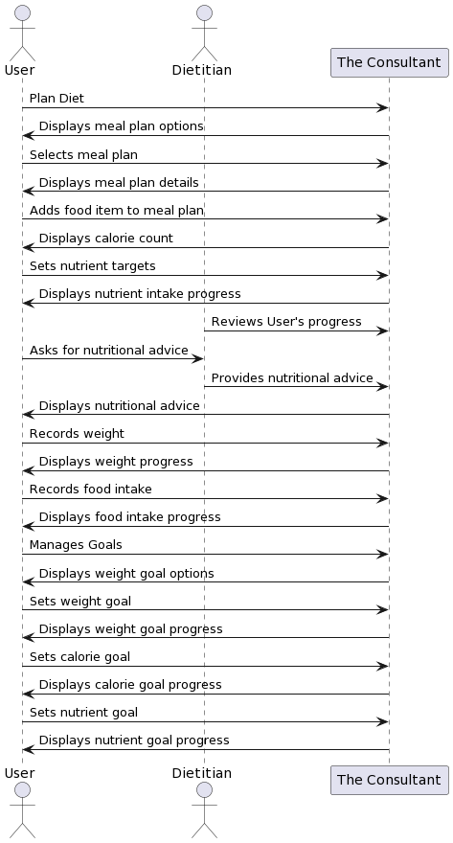

This interaction model shows how the user can use "The Consultant" to create and manage their diet plan, and how the dietitian consultant can use the same system to provide personalized advice and review the user's progress. It also shows how the system supports these interactions by generating meal plans, tracking progress, and facilitating consultations between the user and the dietitian consultant.

**Structural Model**

**Class diagram**

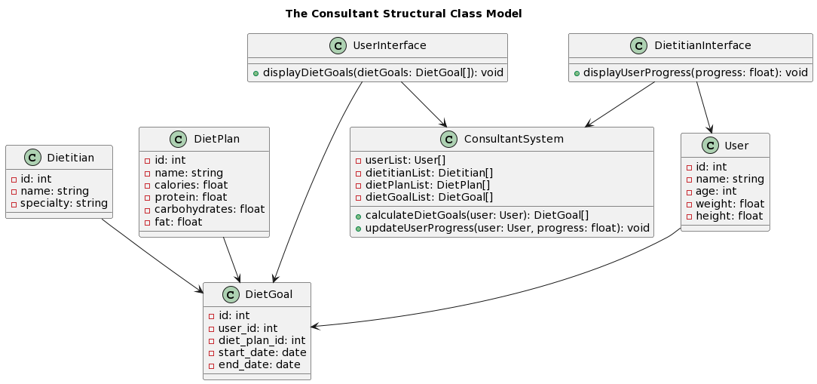

The model defines five classes: User, Dietitian, DietPlan, DietGoal, and ConsultantSystem. The "User" class stores user information, "Dietitian" stores information about dietitians, "DietPlan" stores information about diet plans, and "DietGoal" stores information about user's diet goals.

The "ConsultantSystem" class manages the application logic and contains methods for calculating diet goals and updating user progress. The "UserInterface" and "DietitianInterface" classes connect to the "ConsultantSystem" class to display information about diet goals and progress. Relationships between the classes include "displays", and "uses".

**Behavioral Model**

Data Flow Diagram

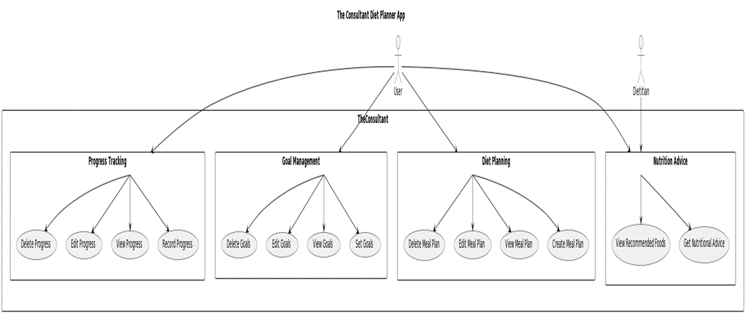

This shows the major components of The Consultant Diet Planner App, including the Diet Planning, Goal Management, Progress Tracking, and Nutrition Advice features. The User interacts with each of these components to plan their diet, manage their goals, and track their progress. The Dietitian can provide nutritional advice to the User through the Nutrition Advice component.